ADDITION AND SUBTRACTION
OCR Thursday 05 November 2020- Morning (Non-Calculator) Foundation Tier
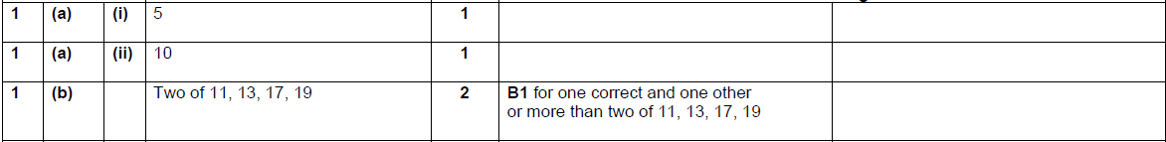

OCR Thursday 07 November 2019- Morning (Non-Calculator) Foundation Tier

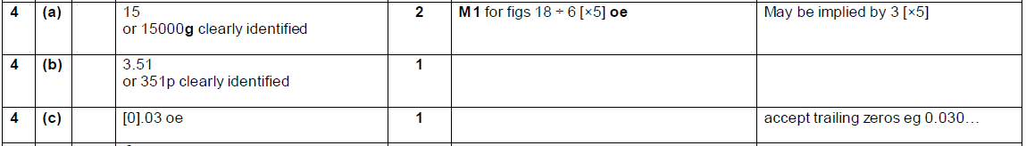

OCR Monday 11 November 2019 – Afternoon (Calculator) Foundation Tier

OCR Tuesday 21 May 2019 – Morning (Calculator) Foundation Tier
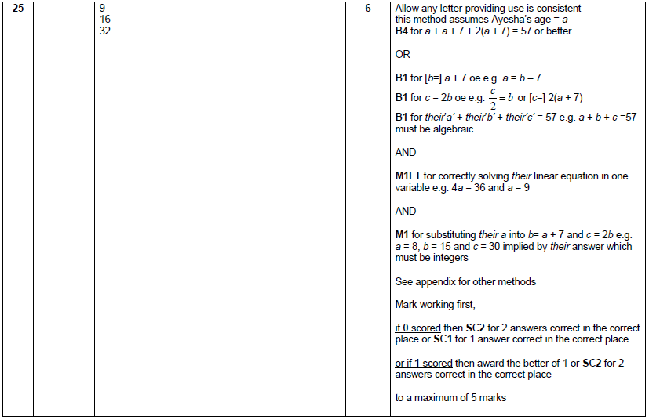

OCR Thursday 6 June 2019 – Morning (Non-Calculator) Foundation Tier
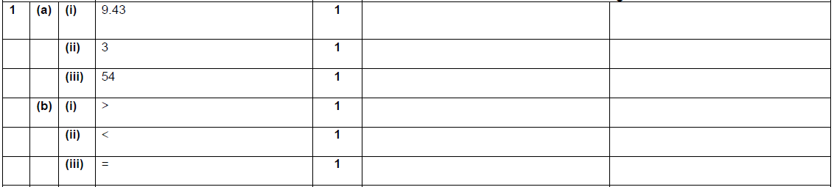

OCR Thursday 8 November 2018 – Morning (Non-Calculator) Foundation Tier
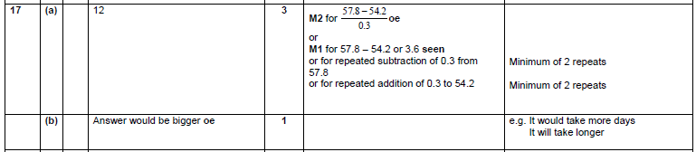

OCR Monday 12 November 2018 – Morning (Calculator) Foundation Tier

OCR Wednesday 8 November 2017– Morning (Calculator) Foundation Tier

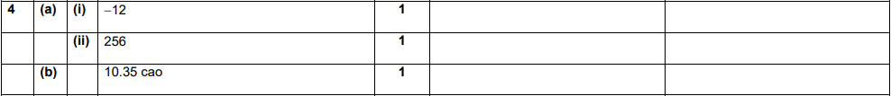
AQA Tuesday 19 May 2020 – Morning (Non-Calculator) Foundation Tier

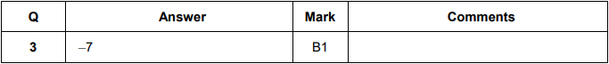

AQA Tuesday 21 May 2019 – Morning (Non-Calculator) Foundation Tier

AQA Tuesday 6 November 2018 – Morning (Non-Calculator) Foundation Tier

AQA Thursday 24 May 2018 – Morning (Non-Calculator) Foundation Tier

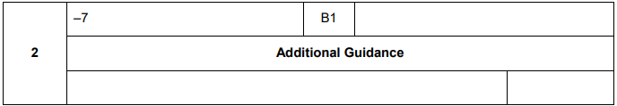
AQA Thursday 2 November 2017 – Morning (Non-Calculator) Foundation Tier

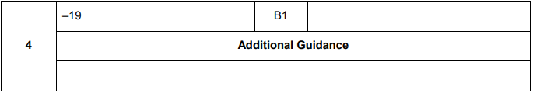
AQA Sample Paper 1– Morning (Non-Calculator) Foundation Tier

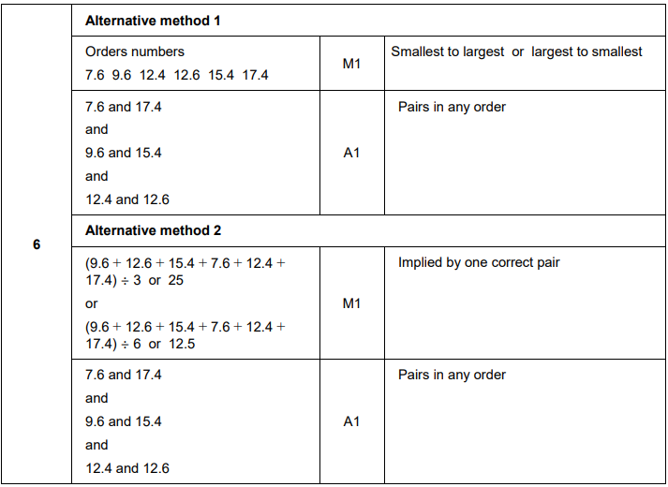
AQA Sample Paper 2– Morning (Calculator) Foundation Tier

